
Profile pic: Attached in the folder
LinkedIn button: with hyperlink here
Email button: with hyperlink email to rohith@zodhyatech.com

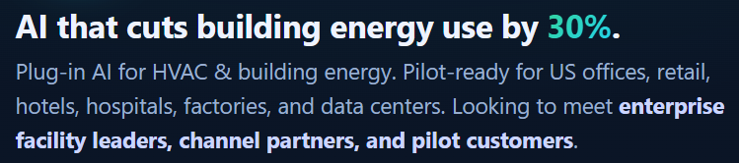
A decade of experience on building intelligent, adaptive systems using IoT, AI, and automation, with a deep interest in solving energy challenges across buildings, grids, and emerging environments like space.
Today, here’s what my startup Zodhya does:
Plugin intelligence that orchestrates, operates and optimises energy real-time across any asset-class: buildings, grids or distributed sources
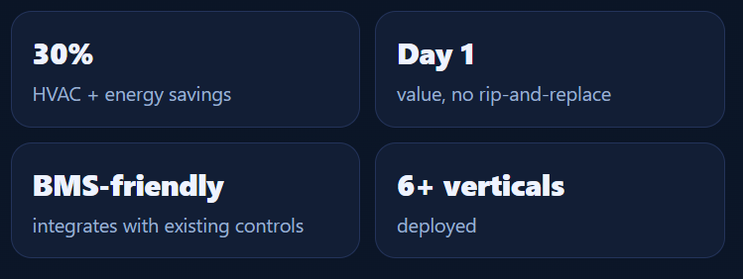
Replace the box text with below text
Box 1 : 30%: energy savings and peak demand reduction
Box 2: Day 1: Performance without any delays
Box 3: Interoperable: Can integrate with any system BMS/ non-BMS
Box 4: Autonomous: Not just analysis, but control that is quick and reliable
Now include the below text:
Website: (globe icon) hyperlink Zodhya’s website https://www.zodhyatech.com/
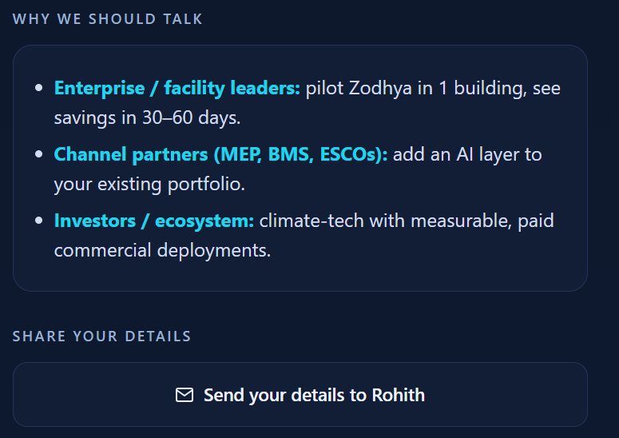
Remove the above
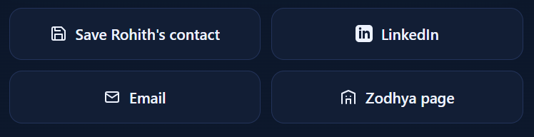
- Save Rohith’s contact
- Linkedin button Remove
- Email button Remove
- Instead of Zodhya’s page: Share your details to Rohith
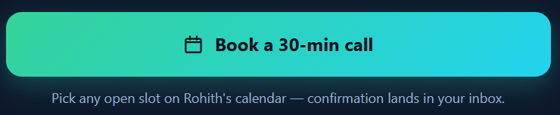
Book a quick catchup call

